# Study about the comprehensibility of government letters

In this letter you will read more about our study about whether government information is clear.

## What is this study about?

Information from the government is sometimes hard to understand. The government tries to improve her websites and letters. They would like to know if this worked. What is working well and what is not. The government has asked us (the HAN) to find out. We do that by inviting you and other people to read some letters and web pages.

## What are we going to do?

The study goes as follows:

1. We invite you to come to the HAN in Arnhem:
2. We ask you a few questions to get to know you, for example: do you enjoy reading?
3. We turn on the eye-tracker. It tracks your eyes so we can see what you are reading;
4. You will read 5 texts on our computer. We will ask you some questions like: What would you do now? Or: What is not clear in your opinion?

The session will take about an hour. You can cancel your appointment any time or quit during the study, without a reason.

## Costs

We will pay for your travel expenses. And as we’re very grateful for your help, you will receive a gift box that includes some tasty goodies.

## What we will do with the results

The session will be recorded on video. The video shows you reading. That way, we can see how the letters and web pages can be improved. We may also show parts of the video to people who work for the government. This helps them learn how to make texts clearer.

If you don’t want us to record your face, we won’t. You can still participate in the study.

We will write a report about the results. In this report we will share how clear the current government information is and how they can improve them. This report will be sent to <name organizations>. Your name won't be in the report.

## Location

The study will take place at the HAN: Ruitenberglaan 25 in Arnhem.  
A few people might observe the session from another room.

## Contact

The researchers are: <name> and <name>. We work for the School of IT and Mediadesign. We do research about improving the usability of websites, apps and texts. We do this because we think it's important that everyone can use the internet and have a pleasant experience.   
Take a look at our website if you want to know more about us 🡺

**Questions?**   
Contact <name>.

Phone:   
E-mail:

This study is approved by the HAN Research Ethics Committee.

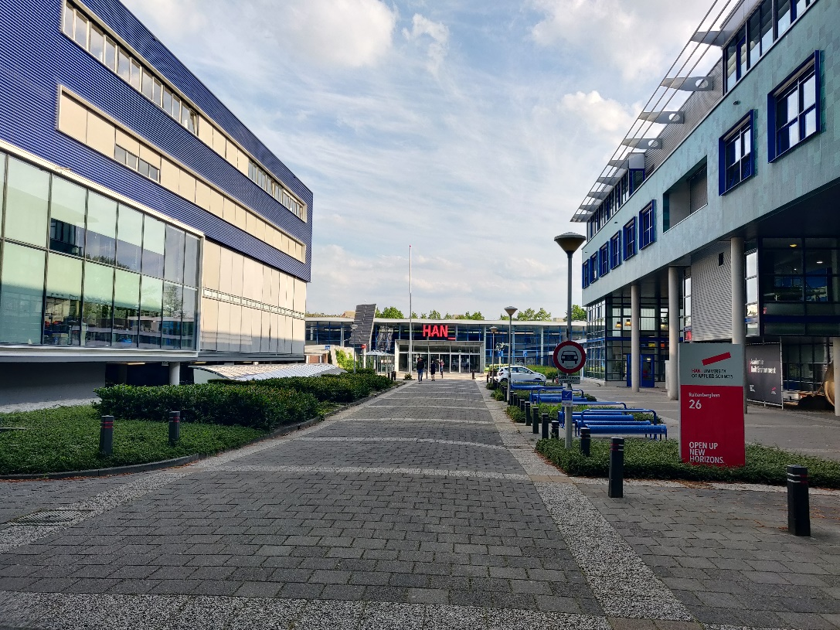

1 ENTRANCE TO THE HAN BUILDING

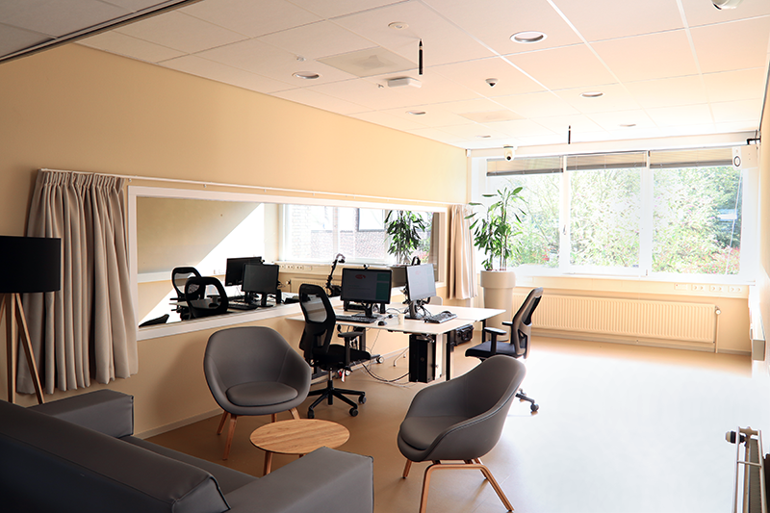

2 ROOM IN WHICH THE STUDY WILL TAKE PLACE